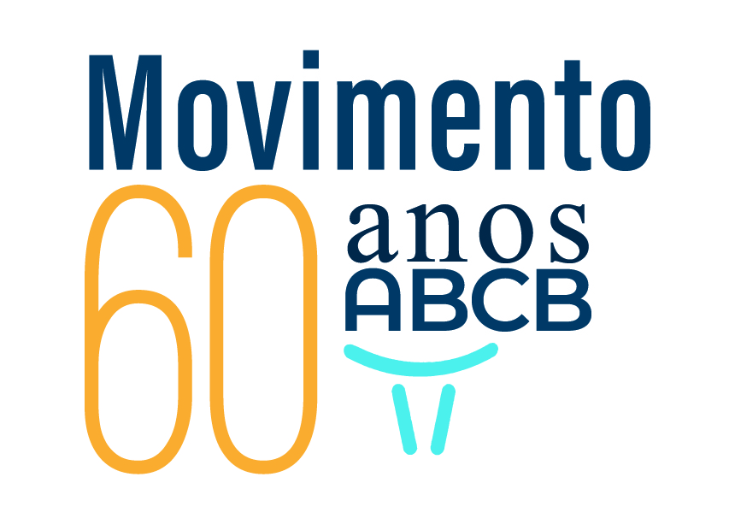

ON APRIL 16 AND 17 YOU ARE OUR GUEST TO TOGETHER CELEBRATE THE 60TH ANNIVERSARY OF ABCB AND OFFICIALLY INAUGURATE THE INTERNATIONAL BUFFALO FEDERATION OFFICE IN BRAZIL.
We reserve the Intercity Ibirapuera Hotel so that together we can enjoy this atmosphere of celebration and celebration.
The lecture " THE FUTURE OF AGRIBUSINESS" will be given by former Minister of Agriculture, Livestock and Supply Dr. Roberto Rodrigues.
The event will have national shows with tasting of the most varied dairy and buffalo meat derivatives and the preparation of an Entire Roast Buffalo.
The presence of Breeders from different countries has been confirmed.
Participate; your presence is very important for ABCB!
Caio Rossato - President
Programming:
DAY: APRIL 16 - THURSDAY - 7:30 PM
Welcome Cocktail (by membership) - BOURBON STREET MUSIC CLUB
Rua dos Chenés, 127 - Moema - SP
www.bourbonstreet.com.br
DAY: APRIL 17-FRIDAY-Faculty of Veterinary Medicine and Animal Science of USP - FMVZ - USP
Venue: Amphitheater of USP - Av. Prof. Orlando Marques de Paiva, 87 - University City - SP
10:00 A.M. - SOLEMN SESSION OF COMMEMORATION OF ABCB'S 60TH ANNIVERSARY AND OFFICIAL INAUGURATION OF THE INTERNATIONAL BUFFALO FEDERATION OFFICE IN BRAZIL.
11:00 AM - LECTURE BY FORMER MINISTER ROBERTO RODRIGUES " THE FUTURE OF AGRIBUSINESS"
12:30 pm - BUFFALO SHOW - Shows of Brazilian products with buffalo meat and milk from various states.
16H30 - COCKTAIL WITH TASTING OF BUFFALO PRODUCTS - with tasting of the most varied dairy and buffalo meat derivatives and the preparation of an Entire Roast Buffalo.
18H00 - CLOSING
Hotel Nominated: Intercity Ibirapuera - website: www.intercityhoteis.com.br
Direct reservations at Hotel Intercity Ibirapuera-(11) 3577.7100/ WhatsApp (11) 9.7321-9552 David
* (indicate event of the Brazilian Association of Buffalo Breeders)
**For bookings until 3/3 special rates for ABCB–tsingle arifa: R$ 385.00+5% double rate: R$ 420.00+ 5%
CONFIRM PHONE PRESENCE: (11) 3673.4455 or email: bufalo@bufalo.com.br



